Country Profile: New Zealand

Photo: MurielBendel, CC BY-SA 4.0, via Wikimedia Commons
Table of Contents
Country Overview
Population and Demographics
Government
Economy
Disease Prevalence
New Zealand Health System
Public Healthcare System
Private Healthcare System
Healthcare Financing
Workforce
Education
Healthcare Outlook
Competitive Landscape
Recent Developments
CSI Assessment

Country Overview

Population and Demographics
Capital | Wellington¹ | Official languages | English, te reo Māori and New Zealand Sign Language²
Population | About 5.36 million (30 June 2026, provisional)³ | Area | 267,710 sq km⁴
GDP (PPP), total | About 305 billion international dollars (2025)⁵ | GDP (PPP), per capita | About 57,350 international dollars (2025)⁶
Government type | Constitutional monarchy⁷ | Head of state | The King, represented by Governor-General Dame Cindy Kiro⁸
Head of government | Prime Minister Christopher Luxon⁹ | Currency | New Zealand dollar¹⁰
Urban population | 84.0% (2025)¹¹ | Population aged 65 and over | 17.6% (2025)¹²
Total fertility rate | 1.57 births per woman (2024)¹³ | Life expectancy at birth | 82.0 years (2024)¹⁴
Ethnic groups (2023 Census) | European 67.8%, Māori 17.8%, Asian 17.3%, Pacific peoples 8.9% (multiple responses allowed)¹⁵

New Zealand's estimated resident population was 5,357,300 at 30 June 2026, according to provisional figures, after growth of 36,400 people (0.7 percent) over the year.³ Natural increase of 18,700 was the lowest since the early 1940s, and net migration added 17,600.³ The median age was 39.3 years for females and 37.8 years for males.³ At the 2023 Census, 67.8 percent of people identified as European, 17.8 percent as Māori, 17.3 percent as Asian and 8.9 percent as Pacific peoples, with some people identifying with more than one ethnicity.¹⁵ About 84 percent of people live in urban areas.¹¹
The population is aging. People aged 65 and over made up 17.6 percent of residents in 2025, the fertility rate was 1.57 births per woman in 2024, and life expectancy at birth was 82.0 years.^{12,13,14} Māori and Pacific peoples have shorter life expectancy than New Zealanders of European ethnicity.¹⁶ For a foreign academic medical center, this points to rising demand for chronic and age-related care in a small, high-income market served mainly by a tax-funded public system.

Government
New Zealand is a constitutional monarchy.⁷ The Governor-General, Dame Cindy Kiro, represents the King, dissolves Parliament before a general election, appoints the government after it and signs legislation on the King's behalf.⁸ Her term was due to end on 21 October 2026 but has been extended to 31 March 2027, so that appointing a successor does not clash with the election.¹⁷ At the 2023 election National won 48 seats and ACT 11, so a National-led government needed New Zealand First's eight seats to secure a majority.¹⁸ Prime Minister Christopher Luxon, whose National Party governs with ACT and New Zealand First, has set the next general election for Saturday, 7 November 2026.⁹
Health is run centrally. Simeon Brown is Minister of Health.¹⁹ The Ministry of Health (Manatū Hauora) oversees the system and administers Vote Health, while Health New Zealand (Te Whatu Ora) has planned and delivered public services nationally since 2022.¹⁶

Economy
New Zealand is a high-income economy, with GDP of about 305 billion international dollars at purchasing power parity in 2025, or about 57,350 per person.^{5,6} Services made up 74.4 percent of the economy in the year ended March 2024, goods-producing industries 20.4 percent and primary industries 5.2 percent.²⁰ GDP rose 0.2 percent in the June 2026 quarter, after a 0.9 percent rise in the March quarter, and grew 1.7 percent over the year ended June 2026.²⁰
The Treasury's Pre-election Economic and Fiscal Update, presented on 29 September 2026, describes an economic recovery that has been delayed rather than derailed, first by the hit to confidence from United States tariffs in 2025 and then by the conflict in the Middle East.²¹ Stronger tax revenue in 2025/26 left the deficit, measured as OBEGALx, $3.3 billion (US$1.87 billion) smaller than projected in Budget 2026, and the Treasury expects both OBEGALx and OBEGAL to reach surplus in 2028/29.²¹ It warns that by 2030/31 New Zealand Superannuation and finance costs will take about 28 percent of the tax take, and that over the long term, unless checked, demographics will make the fiscal position unsustainable.²¹ Projected financial improvements at Health New Zealand also help the fiscal outlook.²¹

Disease Prevalence
Deaths, all causes | 38,737 (2022, preliminary)²² | Deaths from cancers | 10,538 (2022, preliminary)²³
Deaths from ischemic heart diseases | 4,607 (2022, preliminary)²⁴ | Deaths from cerebrovascular diseases | 2,275 (2022, preliminary)²⁵
Leading single causes by death rate (2021) | Ischemic heart disease, Alzheimer's disease and other dementias, stroke¹⁶ | Adults with obesity | 34.2% (2024/25)²⁶
Adults who smoke daily | 6.8% (2024/25); 11.9% in 2019/20²⁶ | Adults who vape daily | 11.7% (2024/25)²⁶
Adults drinking hazardously | 16.6% (2024/25)²⁶ | Adults with high or very high psychological distress | 14.3% (2024/25)²⁶

The Ministry of Health's mortality collection records 38,737 deaths in 2022, a preliminary figure.²² Cancers caused 10,538 of them, ischemic heart diseases 4,607 and cerebrovascular diseases 2,275.^{23,24,25} Measured by death rate, the leading causes in 2021 were ischemic heart disease (100 deaths per 100,000 people), Alzheimer's disease and other dementias (67) and stroke (46).¹⁶
Risk factors are widespread. In the 2024/25 New Zealand Health Survey, 34.2 percent of adults were obese, up from 31.3 percent in 2019/20, and 46.2 percent met physical activity guidelines.²⁶ Daily smoking fell to 6.8 percent of adults from 11.9 percent in 2019/20, though it remains 15.0 percent among Māori, and 11.7 percent of adults vaped daily.²⁶ One in six adults (16.6 percent) drank hazardously, and 14.3 percent reported high or very high psychological distress, up from 7.4 percent in 2019/20.²⁶ The burden points to sustained demand in cardiology, oncology, neurology and metabolic care.

New Zealand Health System

Public Healthcare System
New Zealand gives permanent residents universal coverage through a system funded from general taxation and overseen by the Ministry of Health.¹⁶ Eligible residents are covered automatically, hospital care is available at little or no cost at the point of use, and the Accident Compensation Corporation funds injury-related care.¹⁶ The Pae Ora (Healthy Futures) Act 2022 replaced the district health boards with a single national entity, Health New Zealand (Te Whatu Ora), and created a parallel Māori Health Authority (Te Aka Whai Ora), which was disestablished in 2024 with its functions moved to Health New Zealand and the Ministry.¹⁶ Most GPs work in self-owned clinics linked to primary health organizations; primary care is funded by capitation and hospitals through a diagnosis-related group model.¹⁶
Governance has been unsettled. A Commissioner, Professor Lester Levy, and deputy commissioners were appointed in 2024 to stabilize Health New Zealand, and in July 2025 the government re-established a board, with Levy as chair for 12 months.²⁷ Mark Darrow replaced him as chair for a three-year term from 1 May 2026.²⁸ In March 2025 Health Minister Simeon Brown said an independent Deloitte review showed the 2022 reforms were "rushed and poorly implemented," and he directed a shift to local decision making.²⁹ Access remains strained: in the 2024/25 Health Survey, 25.5 percent of adults cited the time taken to get a GP appointment as a barrier, and 14.9 percent did not visit a GP because of cost.²⁶ Hospital waits are improving against the government's health targets: in 2025/26, 72.6 percent of people received elective treatment within four months, up from 63.9 percent the year before, and 76.3 percent of emergency department patients were admitted, discharged or transferred within six hours.³⁰

Private Healthcare System
Private care supplements the public system. About 37 percent of people hold private insurance, which is commonly used for faster access to elective surgery, specialist consultations and diagnostics.¹⁶ Private hospitals focus on elective and nonemergency care and are paid through out-of-pocket fees, insurance and Accident Compensation Corporation reimbursements, and nearly all aged residential care is delivered by the private sector.¹⁶
Southern Cross is the largest name in the market. Southern Cross Medical Care Society holds about 60 percent of the health insurance market by customer numbers, and in the year to 30 June 2026 it paid a record $1.8 billion (US$1.02 billion) in claims and returned to a $146.9 million (US$83.5 million) surplus after two years of deficits.³¹ Southern Cross Healthcare describes itself as New Zealand's largest independent healthcare network, with wholly owned and joint venture hospitals; its hospitals and endoscopy clinics cared for more than 118,000 patients in the year to June 2025.³² Evolution Healthcare runs six private hospitals, including Bowen and Wakefield in Wellington, Royston in Hastings, Grace in Tauranga and Anglesea in Hamilton, along with day surgery centers and the Birthcare maternity hospital in Auckland.³³ Australian investor QIC agreed to buy it from Pacific Equity Partners in December 2021.³⁴
The government is making more use of private providers. In March 2025 the Health Minister directed Health New Zealand to offer private providers contracts of up to 10 years for elective surgery, and in July 2025 he announced an additional 21,000 elective procedures over the following year through an "Elective Boost" program.³⁵ In 2026 Health New Zealand signed its first long-term contracts with private hospitals, worth about $300 million (US$170 million) over six years, with Southern Cross Healthcare, The Ascot Hospital and Clinic (Allevia) and Mercy Hospital Dunedin, to treat orthopedic backlogs.³⁶

Healthcare Financing
Current health expenditure, share of GDP | 10.06% (2024); 9.20% in 2012³⁷ | Current health expenditure per capita | US$5,022 (2024, current US$)³⁸
Out-of-pocket share of current health expenditure | 12.7% (2024); 11.8% in 2012³⁹ | Government share of current health expenditure | 77.7% (2023)⁴⁰
Comparison, current health expenditure share of GDP (2023) | New Zealand 10.13%, Australia 10.40%, United Kingdom 10.99%, Canada 11.19%, OECD members 12.75%, United States 16.69%, Singapore 4.49%⁴¹ | Total health spending, 2026/27 (government figure) | NZ$34.2 billion (US$19.4 billion)¹⁹
New Vote Health operating funding, Budget 2026 | More than NZ$5.8 billion (US$3.29 billion) over the forecast period¹⁹

Current health expenditure was 10.1 percent of GDP in 2024, up from 9.2 percent in 2012, and about US$5,022 per person, according to World Bank data.^{37,38} Out-of-pocket spending was 12.7 percent of current health expenditure in 2024, and general government spending covered 77.7 percent in 2023.^{39,40} In 2023 New Zealand's share of GDP was slightly below Australia's and below Canada, the United Kingdom, the United States and the OECD average.⁴¹ Pharmac buys medicines within a fixed budget, and prescription copayments are capped at NZ$5 (US$2.84) per item.¹⁶
Budget 2026, released on 28 May 2026, provides more than $5.8 billion (US$3.29 billion) in new Vote Health operating funding over the forecast period, including a $1.37 billion (US$778 million) annual uplift for cost pressures and demand, and the government says total health spending will reach $34.2 billion (US$19.4 billion) in 2026/27.¹⁹ It funds 24,000 additional planned care treatments and 24,000 additional cancer treatments in 2026/27, among other services.¹⁹

Workforce
Practising doctors | 20,530 (30 June 2025), up 2.6% on 2024⁴² | Doctors per 100,000 people | 388.3 (2025)⁴²
International medical graduates | 42.1% of surveyed doctors; 43.5% of the register (2025)⁴² | Physicians per 1,000 people | 3.61 (2022); 2.71 in 2012⁴³
Nurses and midwives per 1,000 people | 12.3 (2023)⁴⁴ | Nurses with practising certificates | 80,960 (30 June 2026), 43.5% internationally qualified⁴⁵
Hospital beds per 1,000 people | 2.51 (2023)⁴⁶

New Zealand had 20,530 practicing doctors at 30 June 2025, up 2.6 percent on 2024, or 388.3 per 100,000 people.⁴² International medical graduates made up 42.1 percent of doctors responding to the Medical Council's survey and 43.5 percent of those on the register, rising above 60 percent in Whanganui and South Canterbury.⁴² Retention is the weak point: 99 percent of New Zealand graduates are retained after one year, against 40 percent of international graduates after two years.⁴² Māori doctors make up 5.5 percent of the workforce and Pacific doctors 2.7 percent.⁴²
World Bank data put physician density at 3.61 per 1,000 people in 2022, up from 2.71 in 2012 and above the OECD average of 3.43.^{43,47} Nurses and midwives numbered 12.3 per 1,000 people in 2023, and there were 2.51 hospital beds per 1,000 people that year.^{44,46} At 30 June 2026, 80,960 nurses held annual practicing certificates, 4 percent fewer than a year earlier, and 43.5 percent of them qualified overseas.⁴⁵

Education
Medical education is concentrated at the University of Otago and the University of Auckland, and annual tuition ranges from NZ$20,000 (US$11,400) to NZ$40,000 (US$22,700).¹⁶ Auckland's Bachelor of Medicine and Bachelor of Surgery takes six years of full-time study.⁴⁸ Graduates then complete two years of prevocational training as interns (postgraduate years 1 and 2), with four accredited clinical attachments in each year; doctors who pass the NZREX Clinical examination follow the same training.⁴⁹
A third medical school is under construction. In July 2025 the government agreed to establish a medical school at the University of Waikato focused on primary care and rural and provincial practice, committing $82.85 million (US$47.1 million) alongside a $151.86 million (US$86.3 million) contribution from the university.⁵⁰ It will train 120 additional doctors a year, lifting total medical school places from 639 a year in 2026 to 759 from 2028.⁵⁰ Construction of its Hamilton building is scheduled for completion in December 2027, ahead of the first cohort in 2028.⁵¹
Overseas-trained doctors have faster routes in. In July 2025 the Medical Council introduced fast-track registration for GPs trained in the United States, Canada and Singapore, processed within two months, and added Chile, Luxembourg and Croatia to its comparable health system pathway, bringing the list to 29 countries.⁵²

Healthcare Outlook
Demand will keep rising as the population ages: people aged 65 and over were 17.6 percent of residents in 2025, up from 13.7 percent in 2012.¹² Policy is aimed at access and throughput. Budget 2026 adds a $1.37 billion (US$778 million) annual uplift, funds more planned care, cancer treatment, emergency department events and general practice enrollments, and lowers the eligibility age for bowel screening to 56.¹⁹ On supply, the Waikato medical school will add 120 places a year from 2028, and the Medical Council has shortened registration routes for overseas doctors.^{50,52}
The constraints are fiscal and structural. The Treasury projects the government's expense-to-GDP ratio falling below 30 percent by 2030/31 under tight future budget allowances, and it counts on financial improvements at Health New Zealand.²¹ The public system runs on more than 4,000 fragmented information technology systems, and in 2024, 73 percent of New Zealanders said waits for doctors' appointments were too long.¹⁶ The general election is on 7 November 2026.⁹ Its result will shape how far elective surgery continues to be outsourced to private providers, which matters for any foreign partner weighing clinical or advisory work.

Competitive Landscape
Foreign health systems have a small, mainly commercial presence in New Zealand. Icon Oncology Group delivers cancer care through Bowen Icon Cancer Centre in Wellington, a joint venture with Evolution Healthcare, and in early 2019 Bowen became the first Icon facility outside Australia to offer radiation therapy; Icon said in February 2025 that it had introduced clinical trials there.^{53,54} Evolution itself has been controlled by Australian investors since QIC agreed to buy it in December 2021.³⁴ US-based Sanford Health says it has collaborated with the Omni Health primary care network since 2018, and in July 2026 Health New Zealand signed an agreement with UCLPartners in London on digital and AI innovation.^{55,56}
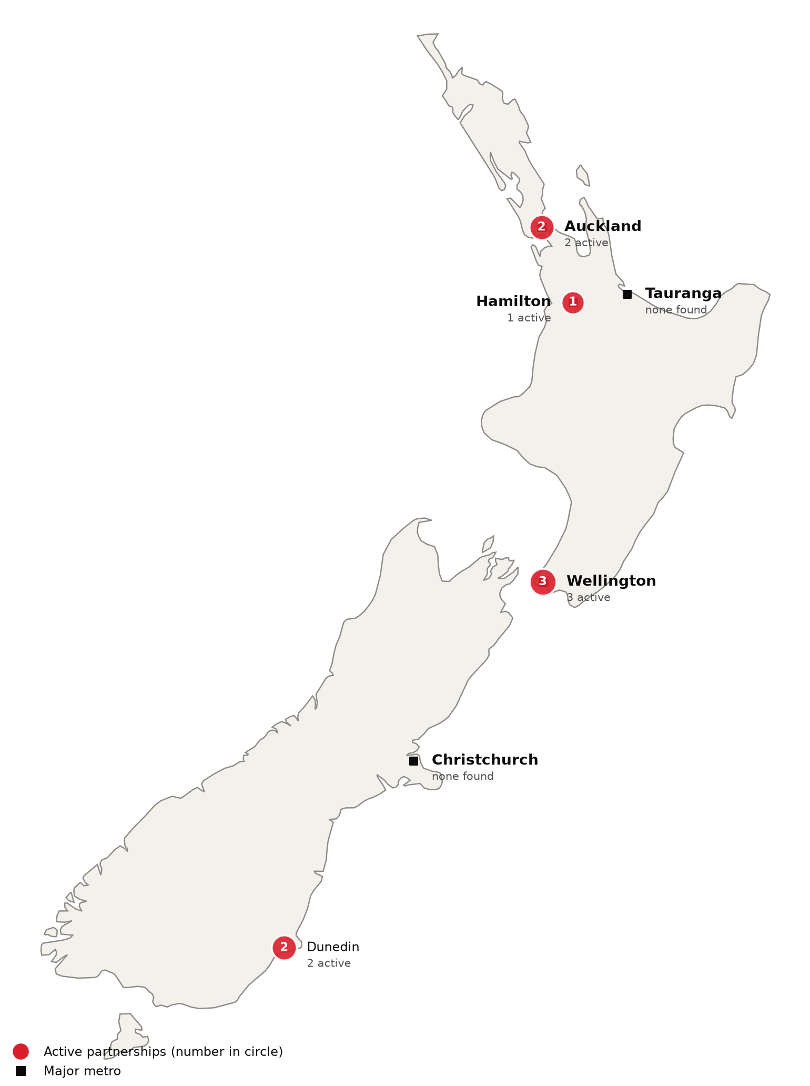
Active foreign health-system partnerships by city of the partner in New Zealand. Source: CSI partnerships tracker, verified 2026-10-21. Boundaries: Natural Earth; not an official depiction.
Confirmed active partnerships by institution
Institution | Based in | Nature of collaboration | Latest evidence
US academic medical centers
Johns Hopkins University (Bloomberg School of Public Health, Center for Indigenous Health) | United States | Research collaboration | 2026-01⁵⁷
Other foreign health systems
Icon Oncology Group (Icon Group) | Australia | Ownership or management | 2025-02⁵⁸
National University of Singapore and National University Health System | Singapore | Research collaboration | 2025-08⁵⁹
UCLPartners | United Kingdom | Advisory and consulting | 2026-07⁵⁶
Universitas Indonesia (Faculty of Public Health) | Indonesia | Training and education | 2025-10⁶⁰
University of Southampton (MRC Lifecourse Epidemiology Centre, EpiGen Global Research Consortium) | United Kingdom | Research collaboration | 2025-08⁶¹
University of Wollongong (Graduate School of Medicine) | Australia | Training and education | 2025-10⁶²
West Visayas State University | Philippines | Research collaboration | 2025-06⁶³
Only partnerships with dated evidence of activity in the last 24 months are listed. Unclear and recently ended partnerships are in the CSI partnerships tracker.
New Zealand is also a regional referral destination. The Ministry of Foreign Affairs and Trade funds the New Zealand Medical Treatment Scheme, which refers patients from Fiji, Kiribati, Samoa, Tonga, Tuvalu and Vanuatu for treatment in New Zealand, Australia and Fiji.⁶⁴ In 2024, 53 people were treated overseas under its referral component.⁶⁵ Outbound, an industry publication reported in 2022 that it was common for New Zealanders to go to Australia for some treatment, and to Asia for dentistry, joint replacement and cosmetic surgery.⁶⁶ There is no official count of New Zealanders treated abroad, though agencies report rising demand, including for Türkiye.⁶⁷

Recent Developments

2026-10 Health New Zealand reports gains on its health targets
Health New Zealand reported that in 2025/26, 72.6 percent of people received elective treatment within four months, up from 63.9 percent, and 66.1 percent received a first specialist assessment within four months.³⁰ It said 87.0 percent of cancer patients were treated within 31 days of the decision to treat and 76.3 percent of emergency department patients left within six hours.³⁰
2026-05-28 Budget 2026 adds more than $5.8 billion (US$3.29 billion) in new health operating funding
Budget 2026 provides more than $5.8 billion (US$3.29 billion) in new Vote Health operating funding over the forecast period, including a $1.37 billion (US$778 million) annual uplift, and the government says total health spending will reach $34.2 billion (US$19.4 billion) in 2026/27.¹⁹ It also lowers the bowel screening eligibility age to 56.¹⁹
2026-04-16 New Health New Zealand board chair appointed
The Health Minister appointed Mark Darrow as chair of the Health New Zealand board for a three-year term from 1 May 2026, replacing Lester Levy.²⁸
2025-07-15 Medical Council fast-tracks registration for US, Canadian and Singaporean GPs
The Medical Council introduced fast-track registration for GPs trained in the United States, Canada and Singapore, processed within two months, and added Chile, Luxembourg and Croatia to its comparable health system pathway, which now covers 29 countries.⁵²
2025-07 Third medical school approved at the University of Waikato
The government agreed to establish a medical school at the University of Waikato focused on primary care and rural practice, committing $82.85 million (US$47.1 million).⁵⁰ It will train 120 additional doctors a year, with the first students expected in 2028.⁵⁰

CSI Assessment

Everything below comes from Cedars-Sinai's internal data (patient referral records, finance, relationship history) and human judgment, not from the research agents. Fields left blank are marked and must be completed by the analyst before this profile is used.
Patient Volume & Revenue (most recent FY)
[MANUAL INPUT REQUIRED]
Referral Sources
[MANUAL INPUT REQUIRED]
Relationship History
[MANUAL INPUT REQUIRED]
Complications
[MANUAL INPUT REQUIRED]
Key Contacts
[MANUAL INPUT REQUIRED]
Opportunities
[MANUAL INPUT REQUIRED]
CSI Recommendation
[MANUAL INPUT REQUIRED]

